
YASAKA- You’re in good hand
Yasaka Fruit Processing Co., Ltd which was established in March 2009, 100% investment capital from Japan, specializing in processing fruits such as dragon fruit by Vapor Heat Treatment technology equipment, automatic selecting size and sweetness testing machine. With modern equipment from Japan, Yasaka’s products have been exported to foreign market such as Japan, Korea, Taiwan, Australia, New Zealand, USA…( you can get more information about my company on website: www.yasaka.vn).
In addition, Yasaka plans to futher expand its range of products as mango, young coconut, rambutan, longan, passion fruit,..etc.
Yasaka achived ISO quality standards and certification of food safety management issued by the Department of Food Hygiene and Safety. We, with professional production management, team of skill workers, Yasaka Fruit Processing Co., Ltd brings high quality products, guaranteed delivery schedule, reasonable price to meet the different needs and needs of customer.

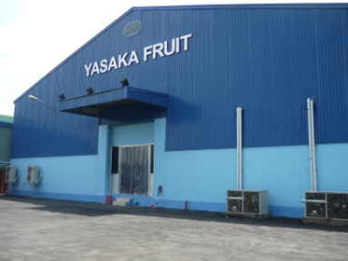
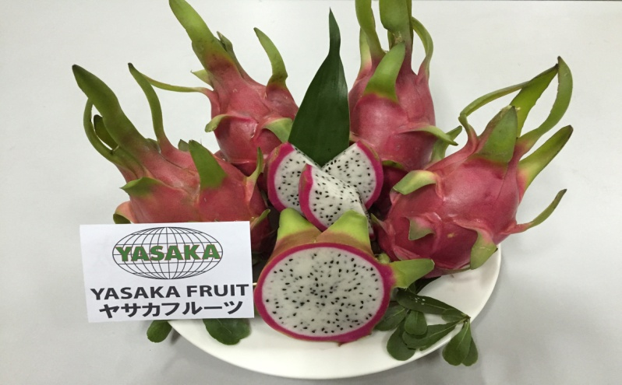
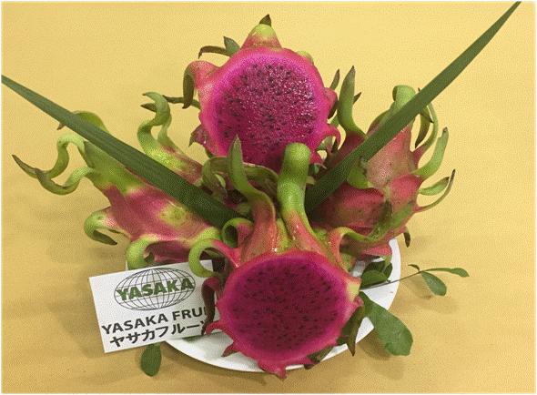

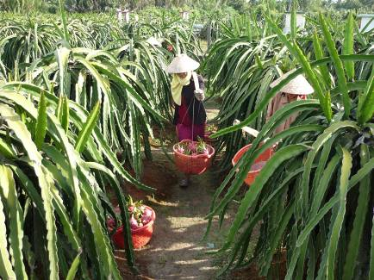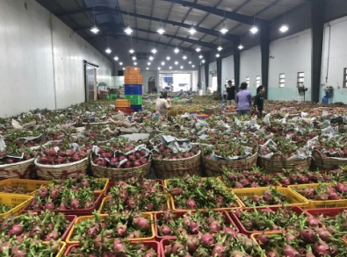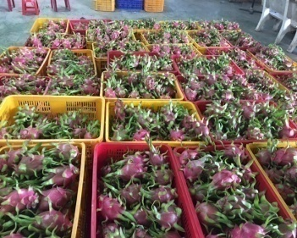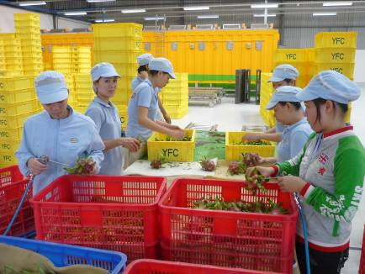
COLLECTING RECEIVING AND CLEANING
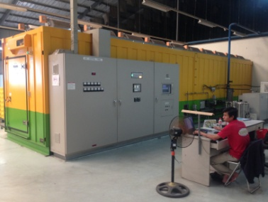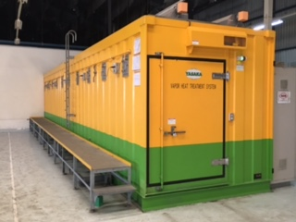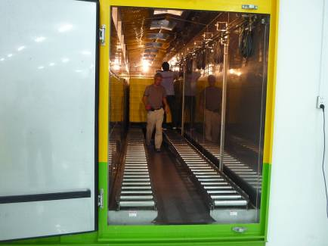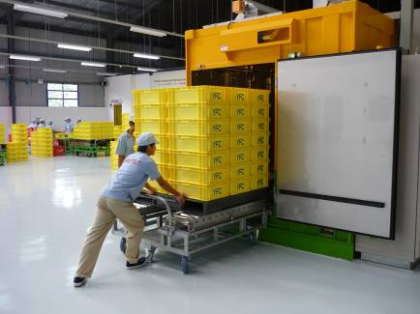
VAPOR HEAT TREATMENT SYSTEM (Technology from Japan)
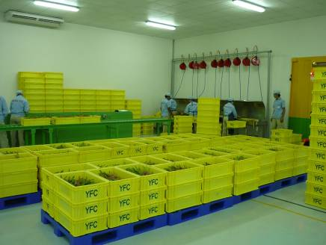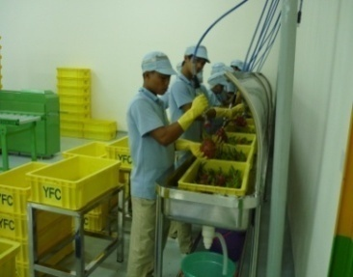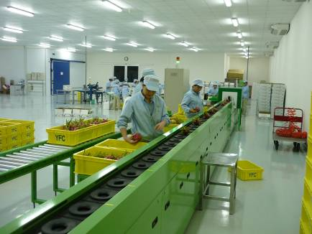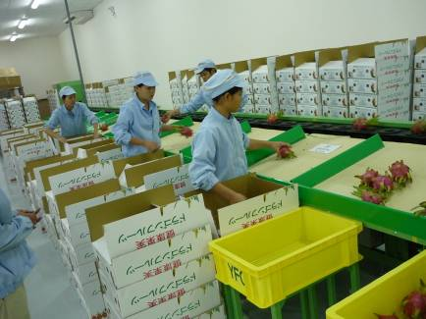
COOLING AND DRYING - SELECTING SIZE AND SWEETNESS TESTING MACHINE
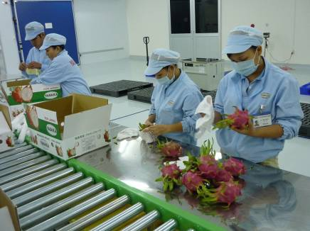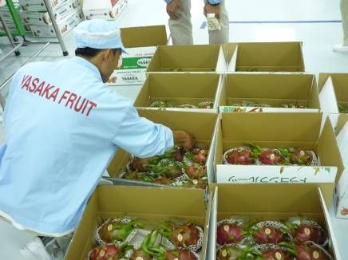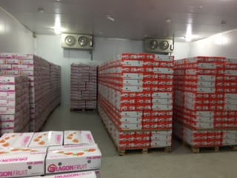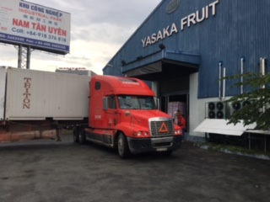
PACKING COLD STORAGE AREA EXPORTING
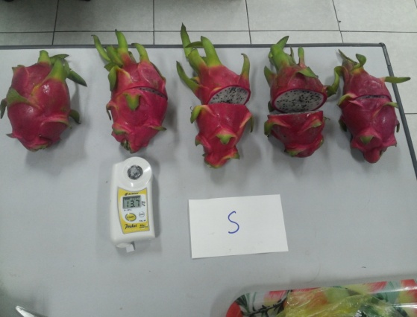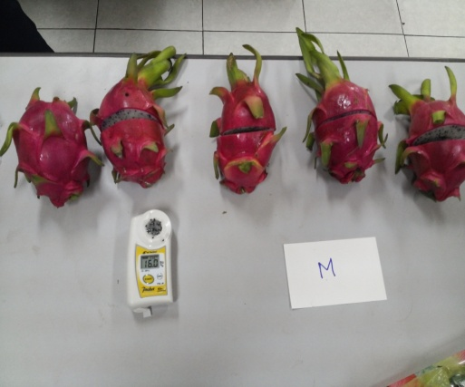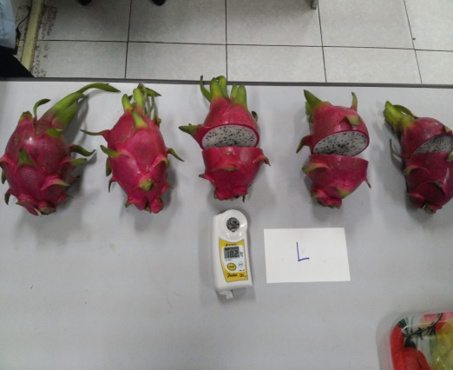
Measuring sweeness (Brix %) S – M – L, 2L, 3L SIZE
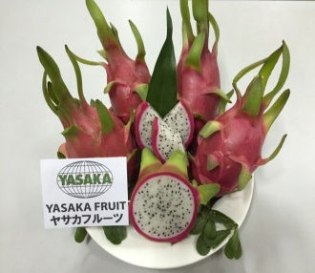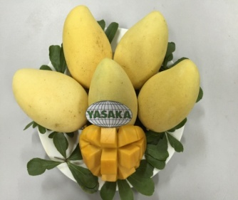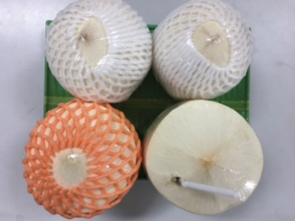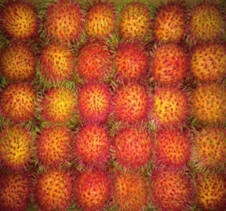

RED-WHITE DRAGON FRUIT MANGO COCONUT RAMBUTAN

Achievement management standards.
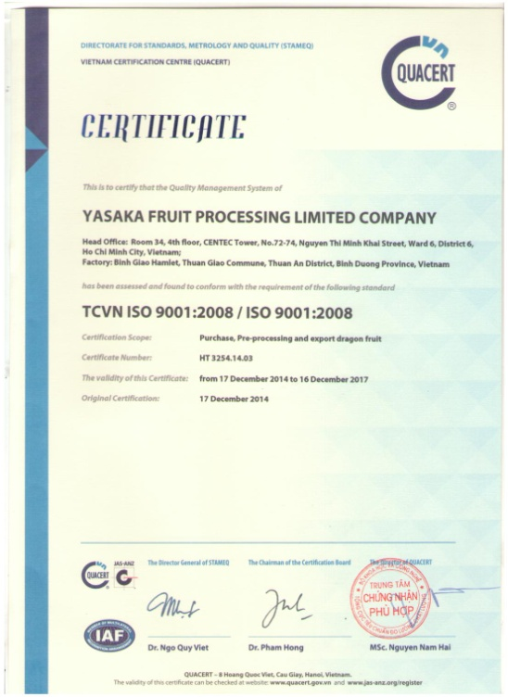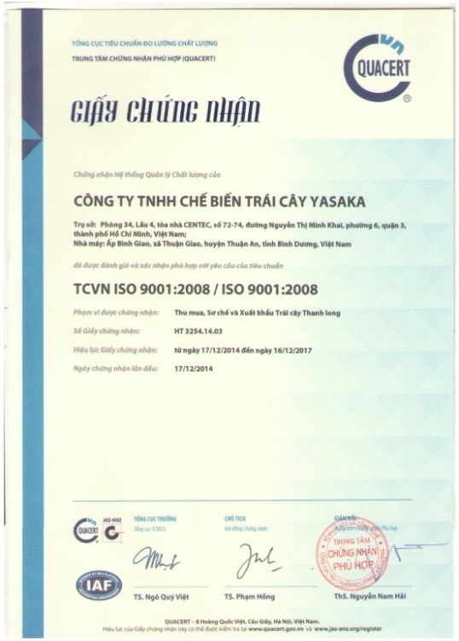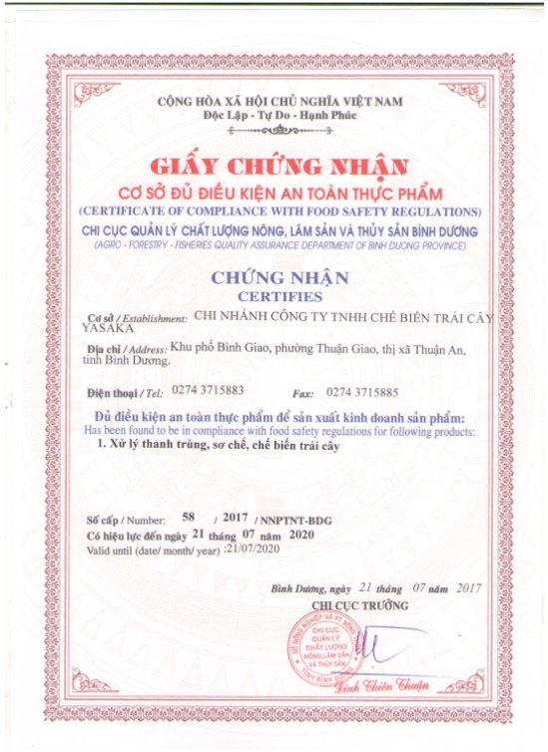

YASAKA FRUIT PROCESSING LIMITED COMPANY
HEAD OFFICE:
No. 034, Floor 4th, Centec tower, No. 72-74 Nguyen Thi Minh Khai street, ward 6, district 3, Ho Chi Minh city, Vietnam
TEL: 0084 28 6299 8290 FAX: 0084 274 3715885 WEBSITE: www.yasaka.vn

FACTORY:
1/106, Binh Duong highway, Binh Giao hamlet, Thuan Giao commune, Thuan An district, Binh Duong province.
TEL: 0084 274 3715882 FAX: 0084 274 3715885

CONTACT PERSON:
Nam Mr.
Sale Manager
Email: namhoang@yasaka.vn
Cellphone: 0084 912871747

