NINH THUAN INDUSTRIAL ZONE MANAGEMENT BOARD
Ninh Thuan Industrial Zones Management Board is a State administrative agency established by the Prime Minister, under the People's Committee of Ninh Thuan province which receives and handles content related to the operation of industrial zones in the province in accordance with the law.
Operating under the "one-stop-in-place" mechanism, Ninh Thuan Industrial Zones Management Board always guides and supports the Enterprises in administrative procedures wholeheartedly.
With the motto "Accompanying with Enterprises", Ninh Thuan Industrial Zones Management Board is always ready to welcome investors to the Industrial Zones in the province with strong belief in the sustainable development cooperation in the future.

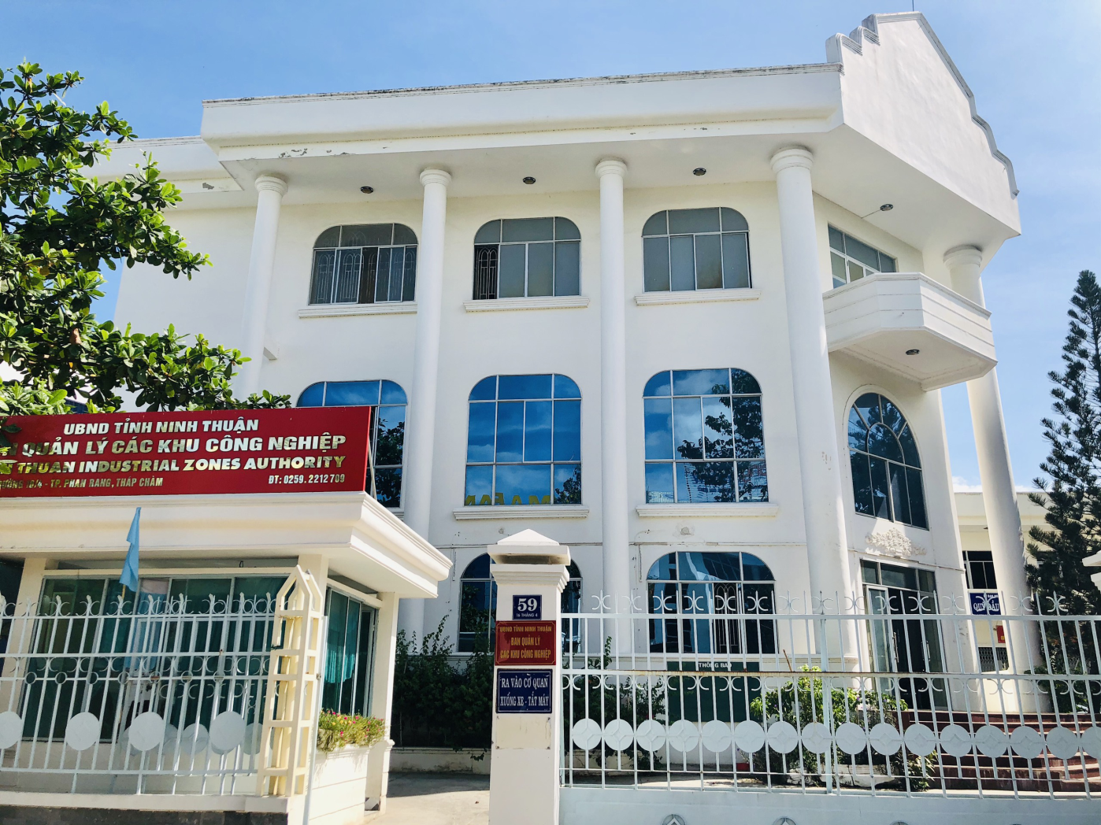
Trụ sở Ban quản lý các Khu công nghiệp tỉnh Ninh Thuận
Head office of Ninh Thuan Industrial Zones Management Board

CONTACT INFORMATION

Address: No.59, 16/4 Street, Phan Rang-Thap Cham city, Ninh Thuan province.
Phone: 0259.2227968 Fax: 0259.3922046
Email: bqlkcn.nt@gmail.com;
Website: www.bqlkcn.ninhthuan.gov.vn
Personal contact:
- Mr. Su Dinh Vinh - Head
Mobile phone: +84.913 882 299
- Mr. Huynh Ngoc Son - Deputy Head
Mobile phone: +84.918 560 261
- Mr. Hoang Ngoc Loi - Head of Division
Mobile phone: +84.703 436 999

OVERVIEW OF NINH THUAN PROVINCE
I. THE NATURAL AND SOCIO-ECONOMIC CONDITIONS

Natural conditions
Geographical location | The North borders on Khanh Hoa province, the South borders on Binh Thuan province, the West borders on Lam Dong province and the East borders on the East Sea.  Phan Rang-Thap Cham city is the second-class city, the political, economic and cultural center of the province. It is 350km from Ho Chi Minh City, 60km from Cam Ranh airport, 105km from Nha Trang city and 110km from Dalat city. This is a convenience for socio-economic development exchanges.
Area | Area is 3,358 km², including 7 administrative units (01 city and 6 districts)
Topography | The terrain is diverse and descending from the Northwest to the Southeast, with three types of terrain: mountains accounting for 63.2%, half-mountain half-plain accounting for 14.4%, coastal plains accounting for 22.4% natural area of the whole province.
Climate and hydrology | The tropical monsoon climate is characterized by hot, dry winds, strong evaporation. The average annual temperature is from 26⁰ – 27⁰C, average rainfall from 700 - 800 mm in Phan Rang city and gradually increases to over 1,100 mm in the mountainous areas. The air humidity is from 75 to 77%. Large radiation energy of 160 Kcl/cm2. Total heat of 9,500 - 10,000⁰C. The weather has two seasons: The rainy season is from September to November; the dry season from December to August.  Ninh Thuan's water resources are unevenly distributed, concentrated mainly in the northern region and the center of the province. Groundwater is only 1/3 of the national average.
Land resources | The total natural area is 335,534 ha, of which land used for agricultural production is 69,698 ha; forestry land: 185,955 ha; aquaculture land: 1,825 ha; land for salt production: 1,292 ha; specialized land: 16,069 ha; residential land: 3,820 ha; land for rivers, streams and special purpose water surface: 5,676 ha; The remaining land area is unused.
Marine resources | The coast is 105.8 km in long, the province's fishing ground is in upland waters with abundant and diverse marine resources over 500 species of seafood. In addition, there is a rich and diverse coral ecosystem with over 120 species and particularly rare sea turtles found only in Ninh Thuan. The coastal area has many bays suitable for tourism development and aquaculture development and shrimp seed production is a strength of the fisheries industry.
Mineral resources. | Metallic minerals include Wonfram, Molybdenum, tin and gold. Titanium in coastal areas with reserves millions of tons.  Non-metallic minerals include crystal quartz, granite, glass sand, ceramic clay ...  Raw materials for the production of construction materials include granite with a total of reserves about 850 million m³, limestone sandstone about 1.5 million m³; coral limestone in coastal areas about 2.5 million tons of CaO; clay additives, stone for construction.
Social conditions
Population | The average population is about 590,467 people in 2019. The average population density is 175.8 people/km², unevenly distributed, concentrated mainly in the coastal plain.  There are three main ethnic groups: the Kinh ethnic group accounting for 75.6%, the Cham ethnic group accounting for 13%, the Raglay ethnic group accounting for 11%, the rest are other ethnic groups.
Labor resources | The working age population is about 343.7 thousand people in 2019, accounting for about 58.2% of the provincial population; The rate of trained laborers reaches about 58.2%. Labors in agriculture, forestry and fishery accounts for 44%, construction industry accounts for 21%, service sector accounts for 35%.
Training | The system of training schools includes branch of Ho Chi Minh City University of Agriculture and Forestry in Ninh Thuan province, Pedagogy College, Political School, Irrigation University, Ninh Thuan Vocational Colleges, Central Institute of Applied and Scientific Training, Vocational Education Centers and Continuing Education Centers of districts and cities train workers with professional qualifications and skills.
Health | There are 241 medical examination and treatment facilities with the total number of doctors and nurses is 1,898 people. Including the Provincial General Hospital (800 beds). Thuan Bac and Thuan Nam district hospitals (100 beds); Ninh Phuoc district hospital, Ninh Son hospital, Saigon - Phan Rang General Hospital; Traditional Medicine Hospital, Provincial Centers for Disease Control.
Infrastructure
Traffic net | The 1A National Road run from Ninh Thuan province to Khanh Hoa Province, the 27 Highway and the 27B Highway run to Da Lat city and South Central Highlands. There is a North-South Railway and 100% of communes have favourable roads to the commune center. In addition, Cam Ranh International Airport and Ba Ngoi cargo port (one of 10 major seaports of the country) in Khanh Hoa province are quite near Ninh Thuan province (range from 45 km to 60 km), which is one of the favorable conditions for transportation. Besides, Ca Na general seaport is constructing and it can receive ships of over 300,000 tons.
Irrigation | There are twenty one irrigation works with a total reservoir capacity of 215.81 million m³, over 279 km of II and III grade canals, which increase the irrigation capacity to 29,446 ha, the active irrigation area to 45,000 ha, reaching 53.7% of the total cultivated land.
Water supply system | There are four large-scale concentrated water supply systems with total capacity of over 120,000 m³/day-night including Phan Rang - Thap Cham Water Plant with the capacity of 52,000 m³/day-night, Ca Na - Phuoc Nam water plant: 30,000 m³/day-night, Tan Son Water Plant: 8,000 m³/day-night, Phuoc Dan Water Plant: 30,000 m³/day-night, supply to Phuoc Dan town, Ninh Phuoc district. Over 60 water supply systems from surface or groundwater with a scale of 50 - 500 m³/day-night and self-flowing water works serve 148 thousand people.
Power supply system | Electricity is supplied from the national grid system with a direct supply of Da Nhim hydroelectric plant with a capacity of 240 MW. In addition, the support of on-site power sources such as hydropower, wind power, solar power, gas power projects.
Post and Telecommunication | The province's post and telecommunications network has been invested to modernize, ensuring domestic and international communications; ensuring the provision of services at affordable costs and high reliability such as: high-speed information data network, broadband network infrastructure (MAN) for the city under the model of "one system, multi service".

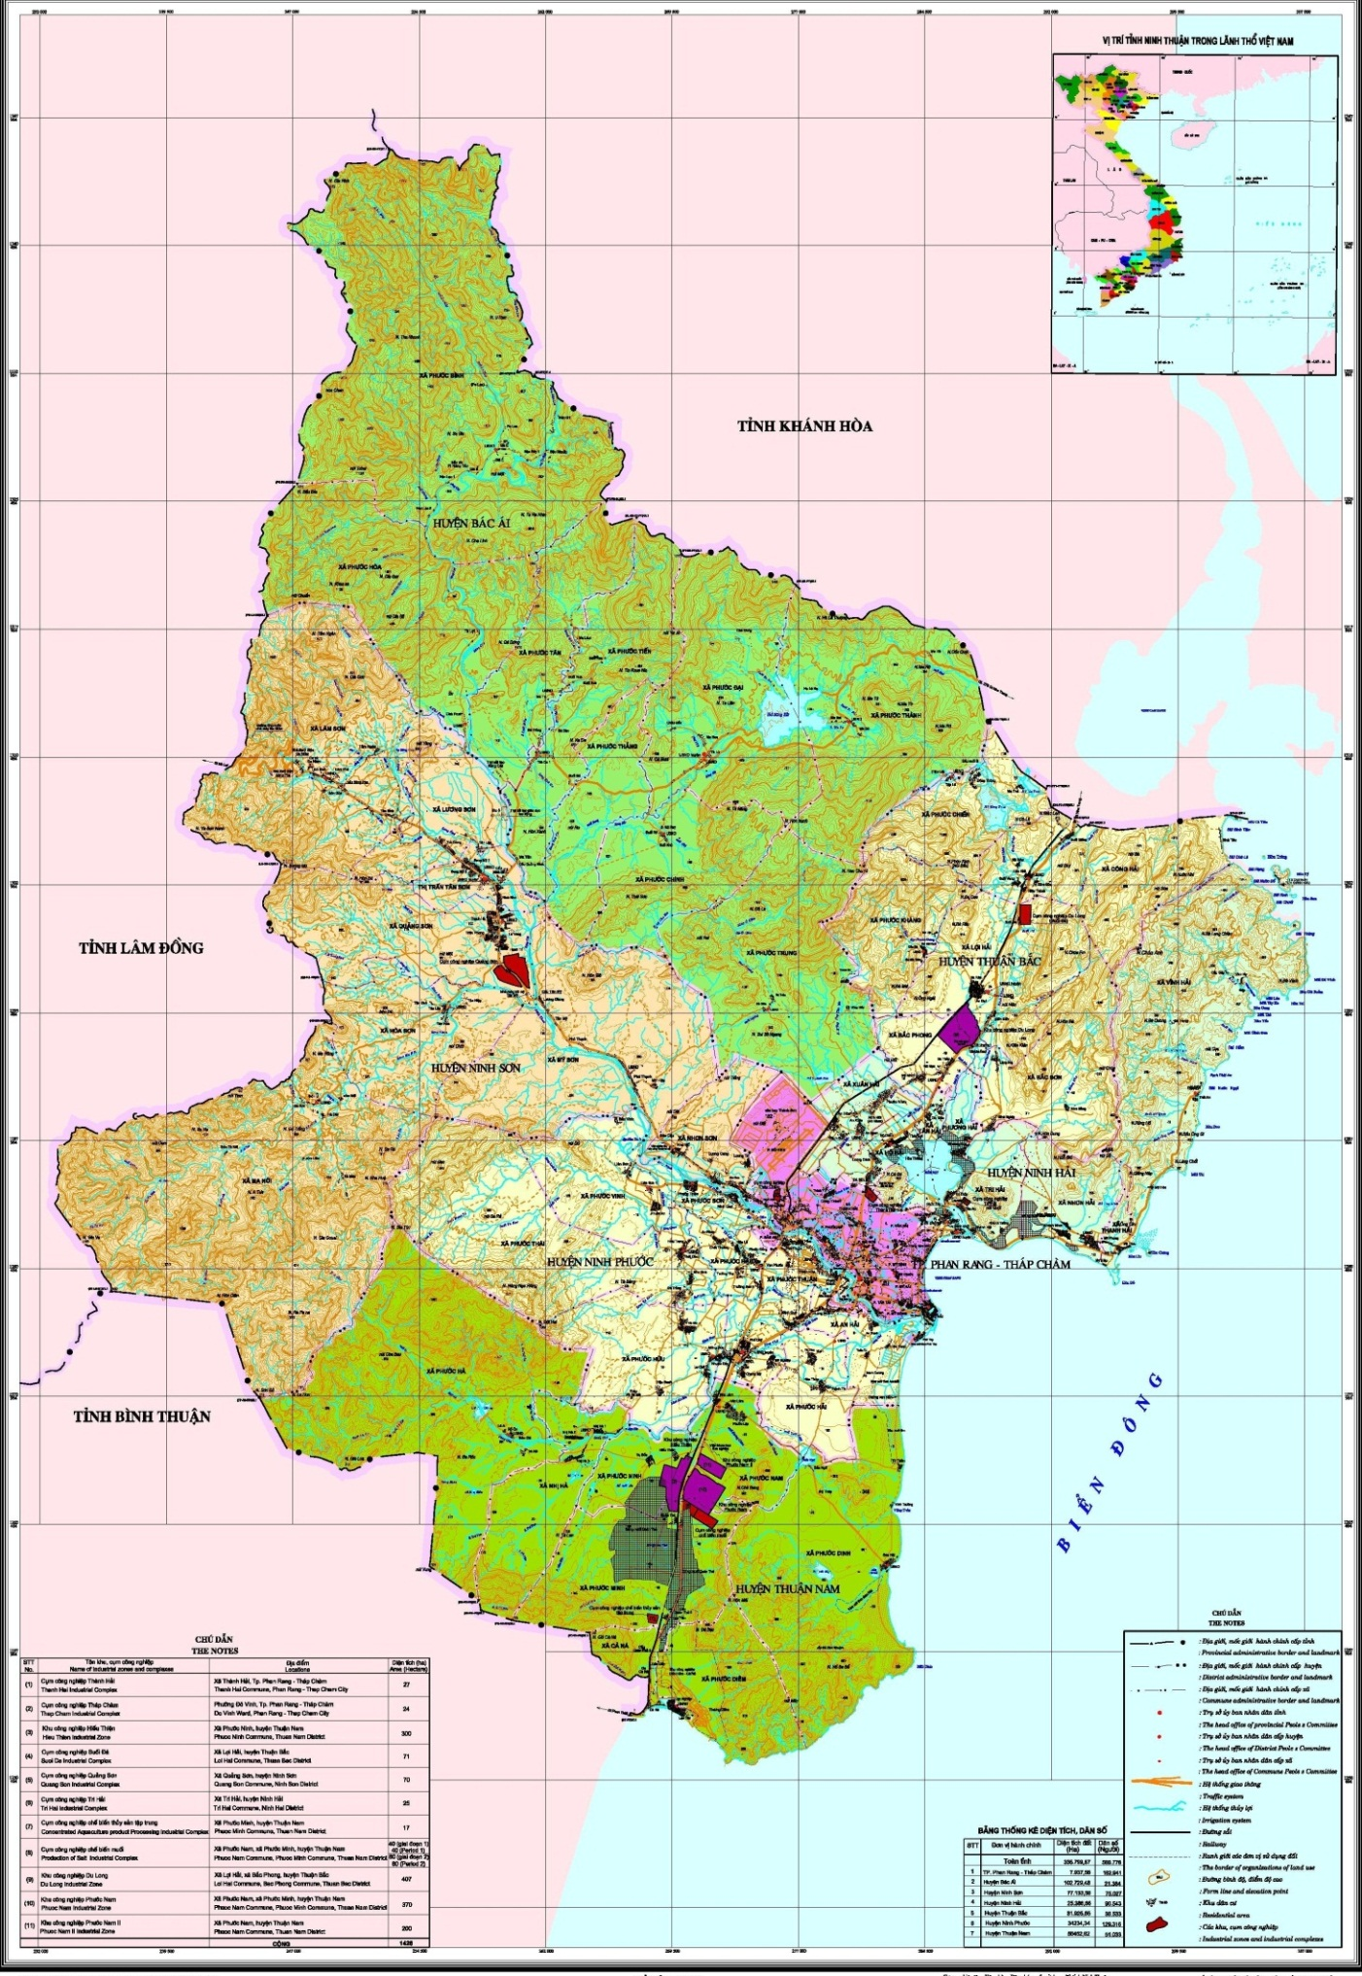
THE MAP OF INDUSTRIAL ZONES IN NINH THUẬN PROVINCE
KCN Ca Na
827,2 ha
Cảng Ca Na
KCN Phuoc Nam
370 ha

KCN Thanh Hai
77,987 ha
KCN Du Long 407,28 ha
NINH THUẬN

INDUSTRIAL parks
I. DU LONG INDUSTRIAL park
The policy of building Du Long Industrial park was approved by the Prime Minister in Document No. 256/TTg-CN dated 14/3/2005 and approved for establishing by the Chairman of People’s Committee of Ninh Thuan in Decision 3848/QD-UBND dated 30/6/2008.
1. Location
Du Long Industrial park, located in the flat terrain, at milestone km 1540 + 598 on National Highway No 1 in Loi Hai and Bac Phong communes, Thuan Bac district is 30 km far from Cam Ranh port of Khanh Hoa province and 20 km far from Phan Rang - Thap Cham city; The fact that it’s bounded by Loi Hai residential area in the North, by Ba Thap residential area in Tan Hai commune in the South, by National Highway 1 in the East, by South-North railway in the West creates favourable conditions for transportation and operation of the industrial park.
2. Investor: Hoa Sen - Du Long Industrial park Infrastructure Investment JSC.
3. Total area
Total area: 407.28 ha.
4. Features and sectors calling for investments
Du Long is an environmentally friendly centralized industrial park. There will be various factories specializing in electronic and informatic equipment assembling; high-tech industries; motorcycle and automobile assembling; machine manufacturing for agriculture and industry; building materials; agricultural, aquacultural and forest product processing industry; consumer goods production factories.
5. The investorand business in infrastructure at industrial park
Hoa Sen - Du Long Industrial park Infrastructure Investment JSC.
II. PHUOC NAM INDUSTRIAL park
The policy of building Phuoc Nam industrial park was approved in the Prime Minister by Document No. 1050/TTg-CN dated 06/7/2006 and approved for establishing in the Chairman of People’s Committee of Ninh Thuan by Decision 3849/QD-UBND dated 30/6/2008.
1. Location
It is situated in Phuoc Nam commune, Ninh Phuoc district, Ninh Thuan province (Km 1574 on National Road 1; 15 km away from Phan Rang - Thap Cham City in the North; 10 km away from Ca Na Resort in the South; 120 km away from Nha Trang City; 70 km away from Cam Ranh International Airport, 50 km away from Ba Ngoi Port; and 335 km away from Ho Chi Minh City.
2. Area
Total area is about 369.92 ha.
3. Features and Sectors Calling For Investments
Phuoc Nam is an environmentally friendly centralized industrial park - a place for high-tech industries including electronics, automotive, motorcycle; mechanical manufacture, building materials; agriculture-forestry-seafood processing; textile & garment, leather and shoes for export.
4. The investorand business in infrastructure at industrial park
- Phuoc Nam - Ninh Thuan Investment Joint Stock Company
- Email: pnipninhthuan@gmail.com
- Office: No. 19 Thong Nhat street, Phan Rang - Thap Cham City, Ninh Thuan Province
Tel/Fax: (+84) 259. 3827979
III. CA NA INDUSTRIAL park
Ca Na Industrial park was approved by the Prime Minister to convert the Ca Na steel production complex project of Ninh Thuan into Ca Na Industrial park in Document No. 787/TTg-KTN dated 19/5/2011.
1. Total Area
General planning scheme to build Ca Na urban area, Thuan Nam District (including Ca Na industrial park) was approved by the People’s Committee of Ninh Thuan Province by Decision No. 480/QD-UBND dated 31/12/2014.
The Prime Minister has approved to adjust the planning area size of Industrial park of 827.20 hectares (Document No. 620/TTg-KTN dated 05/5/2015 on the adjustment of development planning of industrial parks in Ninh Thuan up to 2020).
2. Location: Thuan Nam District, Ninh Thuan Province
2. Status
* Road: National Road 1 (asphalted road with 27 m width, road surface of 14 m); district routes starting from National Road 1 to center of Phuoc Diem Commune (12 m width, road surface of 10 m). According to traffic development orientation in the area, there is a coastal road crossing Ca Na area.
* Railway: Thong Nhat Railway alongside to the West, Ca Na Station (it is now a passing station). In the future, it will be improved to cargo station combined with passenger station.
* Waterway: According to master plan towards 2025, it will be upgraded to local integrated port of class II (total area: 430 ha; land area: 176 ha; water surface: 254 ha) with capacity to receive ships of 300,000 tons and Ninh Chu cargo port will be upgraded to receive ships of 10,000 tons.
* Airway: 90 km away from Cam Ranh International Airport.
3. Features of Ca Na Industrial park
Being a concentrated industrial park, Ca Na is planned to develop sectors of new energy and renewable energy to make use of wind and sun resources in the area. In addition, Ca Na Industrial park tends to develop other sectors including mechanical manufacturing and hi-tech, other heavy industry.
Prioritized sectors: Mechanical manufacturing technology; Renewable energy technology; Traditional energy technology; Mineral processing technology; Test production and research area, other heavy industry.
IV. THANH HAI INDUSTRIAL park
Thanh Hai Industrial park approved by the Prime Minister to convert from Thanh Hai Industrial Cluster into Thanh Hai Industrial park by Document No. 620/TTg-KTN dated 05/5/2015 and was established under Decision No. 1409/QD-UBND dated 25/6/2015 by Chairman of the PPC of Ninh Thuan.
1. Location
* Thanh Hai Industrial park is located in the intersection of 03 strategic traffic axes including National Highway 1, North-South Thong Nhat Railway, National Highway 27 to Southern Central Highlands, connecting to big cities such as Da Lat, Nha Trang and Ho Chi Minh City, 4 km away from Phan Rang - Thap Cham City.
* Location: Thanh Hai Commune and Van Hai Ward, Ninh Thuan Province with the main contents are as follows:
- The East: borders the road according to the approved planning (width B = 27 m)
- The West: borders National Highway 1
- The South: borders the road according to the approved planning (width B = 27 m)
- The North: borders Provincial Highway 702
* Area: 77.987 hectares
* Objectives: Becoming a concentrated industrial park with a synchronous and modern infrastructure system meeting demands of advanced production technology; creating international standard quality products with high yield to meet the domestic demands and for export.
2. Characteristics of Thanh Hai Industrial Park
Thanh Hai Industrial park gives priority to develop electronic industry sector, information technology; Construction materials industry; Garment industry; Mechanical industry; Beverages, food processing industry; Seafood processing; Handicraft, Other traditional industries.
3. Investor and business in infrastructure at industrial park
Center for Infrastructure Exploitation and Investment Support under the Industrial parks Authority in Ninh Thuan Province.
- Address of headquarters: 59, 16/4 street, Phan Rang - Thap Cham city, Ninh Thuan province
- Tel: (+84) 259. 2227968, (+84) 259. 2212709 - Fax: (+84) 259. 3922046
- Email: bqlkcn.nt@gmail.com
- Website: http://bqlkcn.ninhthuan.gov.vn

INVESTMENT INCENTIVE POLICIES
No. | Location / field | Land rental | Corporate income tax
I. | Phuoc Nam/Du Long Industrial Zone
1 | Technical infrastructure investment | The project is exempted the land rent for the whole time of project implementation. | - The tax rate of 10% shall apply for a period of 15 years from the starting of production and business activities.  - Tax exemption for 4 years, starting from the time when a taxable income is made and 50% reduction of the payable tax amount for 9 subsequent years.
2 | Các dự án đầu tư thứ cấp |  | - Thuế suất 10% áp dụng trong thời gian 15 năm kể từ khi bắt đầu hoạt động sản xuất kinh doanh.  - The tax rate of 10% shall apply for a period of 15 years from the starting of production and business activities.  - Tax exemption for 4 years, starting from the time when a taxable income is made and 50% reduction of the payable tax amount for 9 subsequent years.
II. | Thanh Hai Industrial zone
 | Secondary investment projects | - Exemption of land rent during project construction period (maximum 3 years).  - Exemption from land rent for 7 to 15 years (depending on each industry) after the construction is completed and the project put into operation. | - The tax rate of 17% shall apply for the first 10 years from the time when a taxable income is made  - Tax exemption for 2 years, starting from the time when a taxable income is made and 50% reduction of the payable tax amount for 4 subsequent years.

OTHER INCENTIVE AND SUPPORT POLICIES

1. Import Tax
- Import tax exemption for imported goods to create fixed assets in according to the provisions of Clause 11, Clause 13, Article 16 of the Law on export tax and import tax No. 107/2016/QH13 dated April 6, 2016.
2. Investment support
a) Supported the development of technical and social infrastructure systems inside and outside the project boundary;
b) Support for training and development of human resources;
c) Credit support;
d) Supported for access to production and business premises; supported for relocation of production establishments out of inner cities and towns;
đ) Supported for science, technology and technology transfer;
e) Supported for market development and provided information;
g) Supported for research and development.
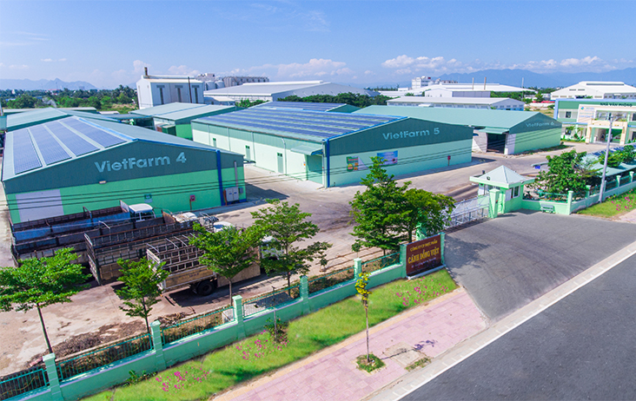

Aloe vera processing factory of Viet Field Food Joint Stock Company in Thanh Hai Industrial Zone

THE LIST OF PROJECTS INVITES FOR INVESTMENT

No. | Name of project | Investment location | Investment objectives | SCALE |  | Current status of the land | Proposed investment capital | Forms of investment
 |  |  |  | Capacity | Area (ha) | Current status of the land | Proposed investment capital | Forms of investment
1 | Wind propeller and wind power body producing plant | Phuoc Nam / Du Long Industrial Zone | Production of propellers, wind power cylinder body to supply domestic and foreign markets. | According to the registered project | 10 | Available ground and technical infrastructure | VND 500 billion | Domestic, joint venture or 100% foreign capital
2 | Solar panels producing plant | Phuoc Nam / Du Long Industrial Zone | Application of high-tech products on solar energy, producing solar panels for households and solar-powered devices. | According to the registered project | 10 | Available ground and technical infrastructure | VND 200 billion | Domestic, joint venture or 100% foreign capital
3 | Mechanical engineering plant | Phuoc Nam / Du Long Industrial Zone | Production of high quality mechanical products for industries (shipbuilding, wind power, solar power, hydroelectricity, and other supporting industries). | According to the registered project | 05 | Available ground and technical infrastructure | VND 150 billion | Domestic, joint venture or 100% foreign capital
4 | Producing plant of auxiliary parts to serve car and engines industry sector | Phuoc Nam / Du Long Industrial Zone | Producing products as high quality accessories and auxiliary parts to serve car engines industry sector and agriculture, forestry and industries, contributing to increase in localization rate. | According to the registered project | 02 | Available ground and technical infrastructure | VND 100 -200 billion | Domestic or 100% foreign capital
5 | Agricultural, forestry and industrial machinery producing plant | Phuoc Nam / Du Long Industrial Zone | Producing high quality mechanical products and machines for agriculture, forestry and industry | According to the registered project | 02 | Available ground and technical infrastructure | VND 100 -200 billion | Domestic or 100% foreign capital
6 | electronic components, telecommunication producing plant | Phuoc Nam / Du Long Industrial Zone | Producing electronic and civil electronic components with advanced technology and little effect on the environment; contributing to increase in localization rate. | According to the registered project | 02 | Available ground and technical infrastructure | USD 30-50 million | 100% foreign capital
7 | Types of construction materials producing plant | Phuoc Nam / Du Long Industrial Zone | Exploiting available local sources of materials to produce construction materials for construction works in the province and neighboring provinces | According to the registered project | 03 | Available ground and technical infrastructure | VND 200 billion | Domestic capital
8 | Consumer goods, garments producing plant | Phuoc Nam / Du Long Industrial Zone | Invest in modern technology equipment to produce high-quality consumer products for the market, create jobs and contribute to the socio-economic development of the province. | According to the registered project | 10 | Available ground and technical infrastructure | VND 200 billion | Domestic or 100% foreign capital
9 | Leather shoes from finished materials producing plant | Industrial zones in province | Invest in modern technology equipment to produce high-quality consumer products for the market, create jobs and contribute to the socio-economic development of the province. | 2 million pairs / year | 3-4 | Available ground and technical infrastructure | VND 30 billion | Domestic, joint venture or 100% foreign capital
10 | Agricultural products processing plant | Phuoc Nam / Du Long Industrial Zone | Processing agricultural products from local materials (such as Grape, Apple, Garlic, Asparagus, Aloe, etc.) to serve domestic consumption and export. | According to the registered project | 2 | Available ground and technical infrastructure | According to the registered project | Domestic capital
11 | Soft drinks, grapes,apples, pineapples juices, aloe and other fruit products producing plant | Industrial zones in province | Producing soft drinks, grapes,apples, pineapples juices, aloe and other fruit products to serve the needs of domestic and foreign markets. | 10 million liters / year | 2 | Available ground and technical infrastructure | VND 100 billion | Domestic, joint venture or 100% foreign capital
12 | Packaging producing plant | Industrial zones in province | In order to take advantages of the available raw materials in the province to produce all kinds of packaging to supply markets inside and outside the province. | 5 million tons of products / year | 4 | Available ground and technical infrastructure | VND 140 billion | Domestic, joint venture or 100% foreign capital
13 | Seafood and canned food; cattle and poultry meat processing plant | Industrial zones in province | Processing aquatic products (shrimp, fish ...), processing cattle and poultry meat (goat, cow, sheep, chicken) contribute to increase the value of commodity products. Providing products of high quality standards, meeting the needs of food, serving domestic and foreign markets | 100,000 tons of products / year | According to the registered project | Available ground and technical infrastructure | VND 300 billion | Domestic or 100% foreign capital
14 | Feed processing plant | Industrial zones in province | Using local materials to produce and process animal feed to serve the domestic market. | 100,000 tons of products / year | 10 | Available ground and technical infrastructure | VND 100 billion | Domestic or 100% foreign capital
15 | Wind turbine generator, electric motor producing plant | Phuoc Nam / Du Long Industrial Zone | Investing in the factory can produce 5,000 tons of components for generator and turbine parts / year. | 5,000 tons of products of all kinds / year | 5 | Available ground and technical infrastructure | VND 650 billion | Domestic or 100% foreign capital
16 | Cosmetics producing plant | Phuoc Nam / Du Long Industrial Zone | Production of cosmetics from raw materials from local Aloe vera tree, such as: body lotion, bleaching, applicating the face ... | According to the registered project | 2 | Available ground and technical infrastructure | VND 120 billion | Domestic or 100% foreign capital
17 | Functional foods producing plant | Phuoc Nam / Du Long Industrial Zone | Producing functional foods from Aloe, Asparagus, and Ninh Thuan Ginseng ... (effect to cool the body, support digestion ...) to supply the domestic market and export. | According to the registered project | 3 | Available ground and technical infrastructure | VND 120 billion | Domestic or 100% foreign capital
18 | Kimchi and vegetables producing plant | Phuoc Nam / Du Long Industrial Zone | Producing vegetables and fruits from local ingredients that meet high quality standards for domestic consumption and export. | According to the registered project | 2 | Available ground and technical infrastructure | VND 120 billion | Domestic or 100% foreign capital
19 | Producing plant of chemicals from salt and after-salt products | Phuoc Nam / Du Long Industrial Zone | To build a producing plant of chemicals from salt and after-salt products such as Sut, Soda, magnesium oxide. | According to the registered project | 10 | Available ground and technical infrastructure | VND 240 billion | Domestic, joint venture or 100% foreign capital

