NEMA2
Organic carbon
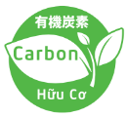

Nema2 is produced by Japan’s technology. It is safe for humans, animals and plants.

- Characteristics:
- Organic carbon  - It is not fertilizer.  - It is not Pesticide.  - No content chemicals.  - Powder, black  - pH > 9.  - Alkalinity and effective antioxidant.  - Easy to dissolve in water and soil.  - The toxic substance is decomposed directly away from useful organic compound. | Nema2: pH >9  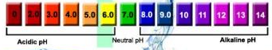  Nema2: ORP -200<  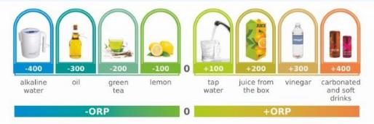  High Alkalinity  Effective antioxidant

- Applications:
- Neutralized PH for soil.
- Deodorized odors, chase the harmful insects out.
- Restored and increased Amino acid.
- Improved and increased immunity of useful microorganism.
- Mixed with microbial fertilizer, organic fertilizer to shorten the process.
- Mix direct or indirect with other material to fertilize.
- Reduced chemical residues of soil, vegetable and fruits.

- Applications in Agriculture:
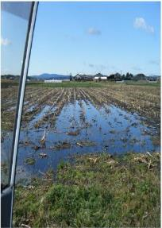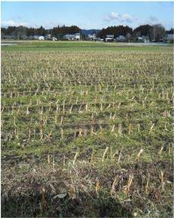  Without Nema2 With Nema2  Fasten drain and reduce flooding. | 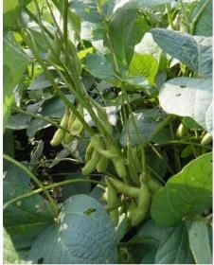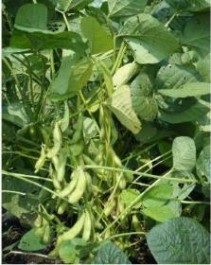  Without Nema2 With Nema2  More productivity
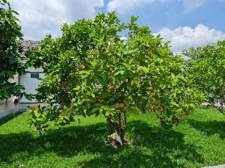  With Nema2  Fruitful, no desease, prevent trees from flies, | 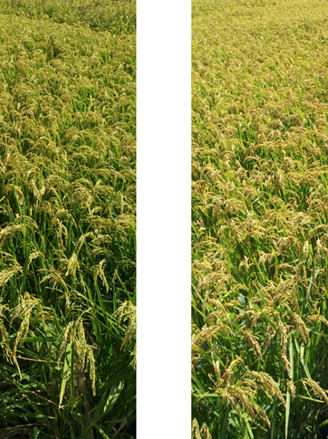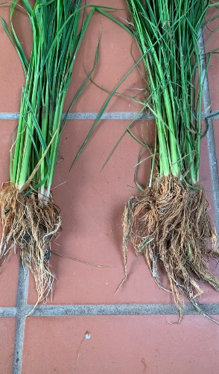  With Nema2  Nutrition roots, strong and tall plants.
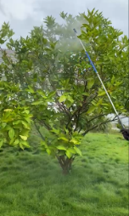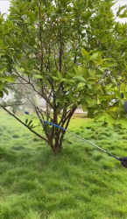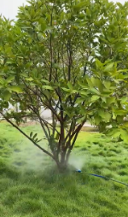  With Nema2  Applied directly into soil, roots, stem, fruits… to improve soil, moisture, promote metabolism and improve plant health. | 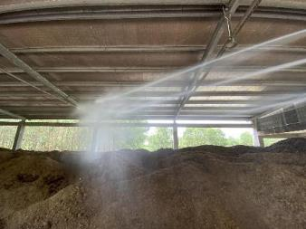  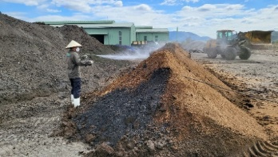  With Nema2  Spray directly to the compost and deodirize the odors.
- How to use:

- A spoonful equals to 5g of powder.
- It’s better to prepare Nema2 solution by dissolving Nema2 with water before using
- After waiting 15-30 minutes, pour the solution into the machine and use.
- Dosage:

- Soil improvement
Nema2 solution: dissolving 100 – 150 gr with 1.000 litre water, 1kg Nema2 apply to 1 hectare (1 time only for a first year).
Spread on the land. Waiting from 14 days to 30 days, then it can apply organic fertilizer or soil conditioner and plowing (if any) before cultivating.
* From the second year, use 500g/1hectare, once per year.
* If need to increase the quantity, it should be consider every crop.

- Plant growth: increase production, productivity, quality of africulture products and fruits.
Nema2 solution: dissolve 100-150g with 1000 Litre water, apply 1kg Nema2 per 1 hectare.
Spread it onto the stems, leaves, buds, fruits, roots and soil.
Spread 3 turns at once time. Once per month.

- Increase gemination of seeds
Nema2 solution: dissolve 10g (or 2 spoonful) into 100 Litre water.
Soak seeds in Nema2 solution within 5-6 hours, then dryed before geminating.
For seedling: soaking roots into Nema2 solution within 20-30 minutes before growing it.

- Composting, increase organic fertilizer and deodorizing odors:
Nema2 solution: dissolve 100kg into 500 Litre water to compost 5 metric ton of fertilizer.
Spray Nema2 solution into organic fertilizer, mix and compost from 30-45 days. Spread compost to soil and plow (if any), starting crop after 1 week.

