NEMA1
Organnic Carbon

Nema1 is safe for humans, animals and plants.

- Characteristics:
- Organic Carbon.  - It is not pesticide.  - It is not chemical  - Powder, black.  - pH > 8,5.  - Alkalinity and effective antioxidant.  - Easy to dissolve in water.  - The toxic substance is decomposed directly away from useful organic compound. | Nema1: pH >8,5  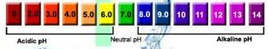  Nema1: ORP -200<  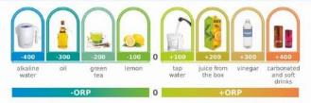  High Alkalinity  Effective antioxidant
- Applications:
- Neutralized environment, reduced air pollution.  - Deodorized odors, decreased Ammoniac and controlled the flies, mosquitos.  - Neutralized acid water and waste water treatment.  - There’s no harm in living beings’  - Purified water  - Reduced chemical residues of vegetable and fruits. | 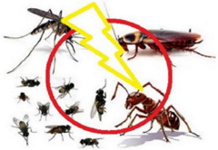

- How to use:
- Dissolve Nema1 based on the direction into water and use after 30 minutes.
- Pour or spray where need.
- Reduced chemical residues of vegetable and fruits by soaking in Nema1.
- Soak meat in Nema1 or spray Nema1 into meat to prevent flies and keep it fresher.

- Deodorized the odors, prevented flies & mosqitos and insect inside or outside of house or office:

- Spray to pollution areas, deodorized and prevented insects:
- Dissolve 50gr-100gr Nema1 with 100- Litre- water (wait for 15-30 minutes), used for 1000 m2.
- Small farm which use equipment, following 10g-20g Nema1 (2-4 cafe spoon) / 20 -Litre- water.
- Detroyed usage: 3 times/ week, maintained during 3 weeks
- Maintainace usage: 2 times/ week
- Spray directly to working area, office, canteen and toillet: can reduce concentration by dissolved 25g Nema1 into 100 litre water and used for 1000m2.

- Using Nema1 powder for deodorizing the odors of holding tank:
- Diluted 10gr or 2 cafe spoon with 1 litre water, after 30 minutes, pour directly into the drain mouth.
- 1 Litre solvent of Nema1 can use for 1.500 litre holding tank.
- Usage: If the ordors apprear, follow the above instructions.

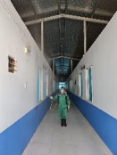

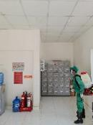
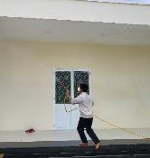
Spray on the ceiling and walls (house and office)

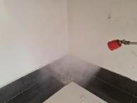

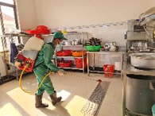
Spray to the kitchen, canteen and drain mouth.

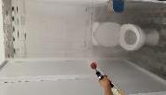
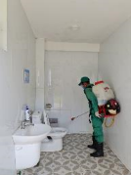


Spray directly where appreared the odors to deodorize.

- Ordors’waste water treatment, prevented flies, insects in the livestock farm:

- Cow farm:

Deodorized, chased the insects out.
Cleaned inside and outside the castle
- Dissolve 50gr-100gr Nema1 with 100 liter water (wait for 15-30 minutes), cleaned 1000 m2.
- Small castle => with equipment, follow this: 10g-20g of Nema1 (2-4 cafe spoon) / 20 litre water.
- Cleaning: 3 times/ week, cleaned during 3 weeks
- Maintaince: 2 times/ week
Spray directly to working area, office, canteen and toillet: can reduce concentration by dissolved 25g Nema1 into 100 litre water and used for 1000m2.
Performance:
- Spray at where ordors apprearred and having a lot of insects.
- Spray on the ceiling, roof, and can spray directly to the food, trough, net, and animals. (This organic is good for animals).
- Spray around play yard, and trenches.
Bath water
- Dissolve 20-30g Nema1 into 1000 litre water, wait at least for 15-30 minutes then used bath water to:
- Clean their bodies
- Clean the floor where they lay down.
- Clean the ceiling: chase the insects and spiders out.
- Spray on the trees around the castle.

Organic compost
- 20g-30g Nema1 dissolve into 3-4 litre water (use after 15-30 minutes), apply for 1m3 compost
- Watering solution on 1m3 compost
- Or dissolve Nema1 which need to use in a week into the 20 Litre tank, watering 3-4 Litre/compost after collect everyday.
- Watering directly on the truck.
- Or watering directly after put it the storage.
Drinking water for cow
- Dissolve 10g Nema1 into 1000 litre water

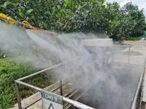Spray into holding tank | 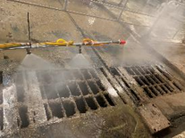Spray into drain | Spray into food

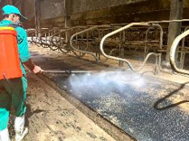Spray into the rest | 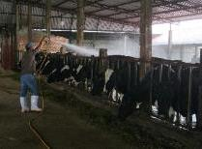Clean directly | 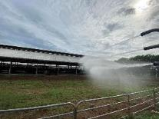Spray the play yard

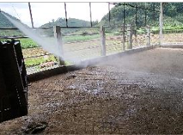Spray on the floor | 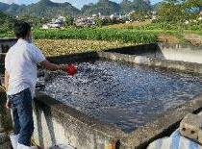Put directly into the drain | 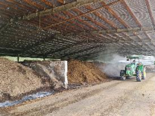Spray in the storage

- Pig farm:

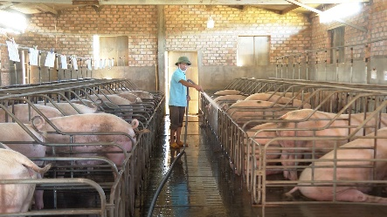


The result:
- No odors. Increased the environment quality and curculation: food, animals, fertilizer, food.
- Pig’s health improvement, good grown-up
- Chase the flies, mosqiutos and insects out.
- No ordors’ waste water, enhanced the soil and no worry about pollution.
- Compost without smell, good reclaimation soil.

How to use:
Deodorized, chased the insects out
Cleaned inside and outside the castle.
- Dissolve 100gr-200gr Nema1 with 100-200 liter water (wait for 15-30 minutes), cleaned 1000 m2
- Small castle => with equipment, follow this: 10g-20g of Nema1 (2-4 cafe spoon) / 20 litre water.
- Cleaning: 3 times/ week, clean during 3 weeks
- Maintaince: 2 times/ week
Performance:
- Spray at where ordors apprearred and having a lot of insects.
- Spray on the ceiling, roof, and can spray directly to the food, trough, net, and animals. (This organic is good for animals).
- Spray around play yard, and trenches
Bath water
- Dissolve 20-30g Nema1 into 1000 litre water, wait at least for 15-30 minutes then used bath water to:
- Clean their bodies
Organic compost
- 20g-30g Nema1 dissolve into 3-4 litre water (use after 15-30 minutes), apply for 1m3 compost
- Watering solution on 1m3 compost
- Or dissolve Nema1 which need to use in a week into the 20 Litre tank, watering 3-4 Litre/compost after collect everyday.
- Watering directly on the truck.
- Or watering directly after put it the storage.

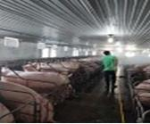  Spray on the floor, walls, and the ceiling | 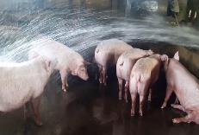  Bath with Nema1 | Spray on the storage

- Livestock farm:

The result:
- Natural environment, without odors, Ammoniac gas.
- Livestock’s health improvement, good grown-up
- Chase the flies, mosqiutos and insects out.
- Reduced the antioxidant.
- Compost without smell, good reclaimation soil.
How to use
Cleaining the castle:
- Dissolve 100-200g Nema1 with 100 Litre water and apply for 1.000 m2
- For small farm, use equipment with 10-20g Nema1 (2-4 Cafe spoon)/10L water/100m2
- Frequency: 2 times/week
Spray directly to working area, office, canteen and toillet: can reduce concentration by dissolved 25g Nema1 into 100 litre water and used for 1000m2.
Performance:
- Use pressure engine or personal sprayer (electric or engine)
- Spray where odors apprear, have a lot of insects.
- Spray on the ceiling, roof, and can spray directly to the food, trough, net, and animals. (This organic is good for animals).
- Spray around play yard, and trenches

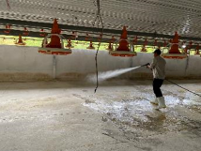Spray on the floor | 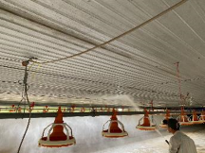Spray on the ceiling |  |  | 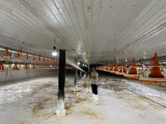Spray on the trenches
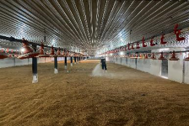 |  | 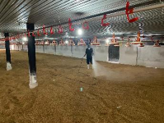 | 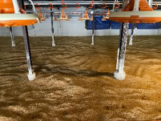

- Apply for cleaning ponds:

- Targeting:
- Deodorized odors and neutralized inorganic of ponds.
- Balanced the PH for fish environment.
- Make the water purity.

- How to use:
- Dissolve Nema1 with water: 1 Litre Nema1/10m2
- 1kg Nema1 can apply to 10,000m2 of pond.
- Spray Nema1 solution all the surface of pond.
- Attack: 2 times/ week, using during 2 weeks
- Maintainance: 1 time/ 2 weeks



